Announcement

The 5th Korea-Japan students' symposium
"Fast ion Transport in Solids and Through Interfaces
– The related materials and phenomena – “

October 27th – 31st, 2004, Seoul, Korea,
Solid State Ionics Research Laboratory
School of Materials Science and Engineering, Seoul National University

Chairperson : Jae-bong Choi(Korea) and Kazuhisa Sato(Japan)

Sponsored by
21st COE of Flow Dynamics, Tohoku University,
Japan-Korea Joint Project for the Future, Japan-Korea Cultural Foundation
Brain Korea 21, Materials Education and Research Division

Korea-Japan Students’ symposium
The Korea-Japan students’ symposium was started four years ago in Seoul, Korea and we have held this symposium in autumn every year in Seoul or Sendai. The last four symposiums achieved great success with the cooperation of all students. The characteristic of the symposium is that students perform a key administrative role in the planning, running, presentation and discussion of the symposium, to encourage students’ initiative.
This year, The Japan-Korea symposium will be held in Seoul, Korea and mark 5th symposium.

The scope of the symposium
The objectives of this symposium are not only to provide a forum for students to discuss the topic concerned with "Fast ion Transport in Solids and Through Interfaces “, but also to build the cultural exchange and good partnership among the students of both universities.

Symposium Schedule
October 27th, 2003 Leave for Seoul, Welcome Reception
October 28th, 2003 Registration, Symposium
October 29th, 2003 Symposium, Tutorial lecture, Banquet
October 30th, 2003 Sightseeing
October 31st, 2003 Departure for Japan,

Symposium Proceedings
Deadline : September 27th 2004
File format : MS word file (See the example on the next page.)
Language : English

Oral Presentations
Presentation : 20min (15min talk and 5min discussion)
Material : OHP or Projector with a note PC
Language : English
Title

Author(s)
Affiliation(s)

Abstract
This is an example of the symposium proceedings. Title, Author(s), Affiliation(s), Abstract and Keywords should be written in one column. After that, the document should be written in a double column format.
Keywords: Seoul national university; Tohoku university; Students’ symposium

1. Introduction
The symposium proceedings size is A4 (297 mm × 210 mm), and the margins should be as summarized in Table 1.

Table 1. The scale of the margins.
Top | Bottom | Left | Right | Column width | Column spacing
20 mm | 25 mm | 20 mm | 20 mm | 80 mm | 10 mm

The symposium proceedings may be 2-4 pages of text, tables and figures.
The preferred font is Times New Roman 14 pt for Title and Times New Roman 10 pt for text.
The text consists of Author(s), Affiliation(s), Abstract (about 200 words), Introduction, Experimental, Results and discussion, Conclusions and References.
Tables and figures must be securely mounted on the page within the outside margins and they may cross the middle margin.

2. Experimental
Make a new MS Word file.
Type Title and so on.
Edit manuscript with mentioned format.

3. Results and discussion

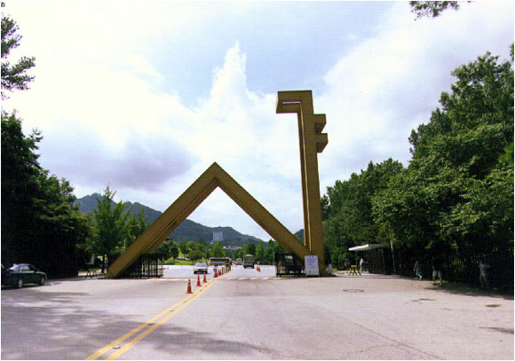
Fig.1. The main gate of Seoul National University

4. Conclusions
The deadline for submission of the symposium proceedings is September 27th, 2004. The electronic files of the proceedings should be submitted to the organizer in your university.

References
[1] D.-K. Lee, K. Yashiro, The First Korea-Japan Students’ Symposium, Seoul Korea, 2000
[2] T. Otake, S.-H. Park, The Second Japan-Korea Students’ Symposium, Sendai Japan, 2001
[3] W.-S. Park, S. Miyoshi, The third Korea-Japan students’ Symposium, Seoul Korea, 2002
[4] T. Sakai, C.-E. Lee, The fourth Japan-Korea Students’ Symposium, Narugo, Miyagi, Japan, 2001

